**POSITIVE OR NEGATIVE**

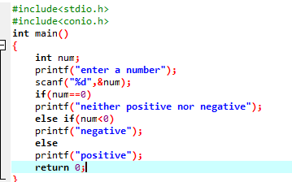

**OUTPUT**

